Remote Learning
Assumption Secondary School

Applications
The applications that will be used for distance learning at Assumption Secondary School will primarily be:
G-Suite
- Gmail
- Google classroom
- Google slides
- Google forms
- Google docs
- Google sites
- Google meet
and
- Zoom
What is distance learning?
Distance learning is a flexible method of study which enables you to study from your home using materials and instructions provided by the school or subject teacher. In the case of distance learning, a class timetable will be shared with each class and new lessons and assignments will be uploaded online through Google classroom and will be visible at the time of each lesson unless otherwise stated. Students will be expected to sign into the Google classroom that corresponds to the class they are timetabled for and log in and engage with the materials provided.

Blended learning approach
Blended learning is a modern approach that combines traditional classroom methods with the use of digital technology. Assumption Secondary School has endeavored to improve access and use of digital technologies and resources for our school community. Our school is committed to improving access to devices for each student in the school. Not every student in our School has access to a device but it is something we are working towards. In order to ease the transition to a potential remote learning situation, Google Classroom is being used in all subjects, in particular when engaging with students' homework.

What will remote learning look like in Assumption Secondary School?
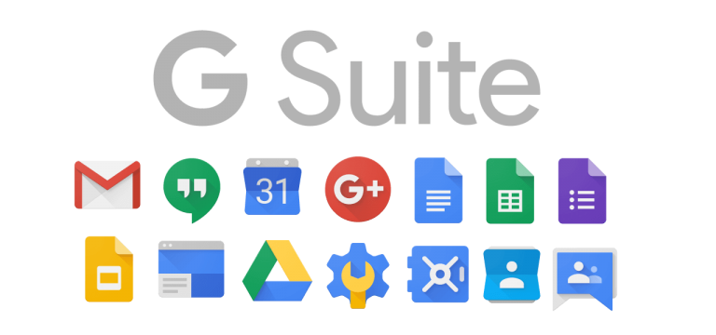
In the event of a school closure, our school will transition to a remote learning format. This means that all the students will continue engaging with the school curriculum but all classes will move to an online setting. This kind of setting is known as an O.L.E. or an online learning environment.
Each student has an active Gmail account that ends with @assumptionss.com. The students’ username and password for their Gmail account will give them access to a whole suite of apps.
Students will send and receive all their work by using Google Classroom. The purpose of this application is to ease the process of sharing and sending files between teachers and students. This method of delivering work will simplify the creating, distributing and grading of school work in an online setting.
When a student logs into Google classroom they will notice a separate class for each of their subjects. Google Classroom is accessed at https://classroom.google.com/
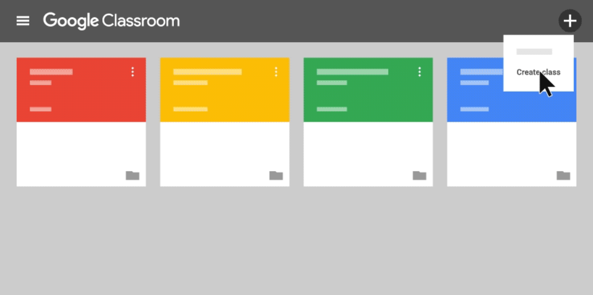
Once the student clicks into their Google class they can look for the latest assignments or communication from the teacher.
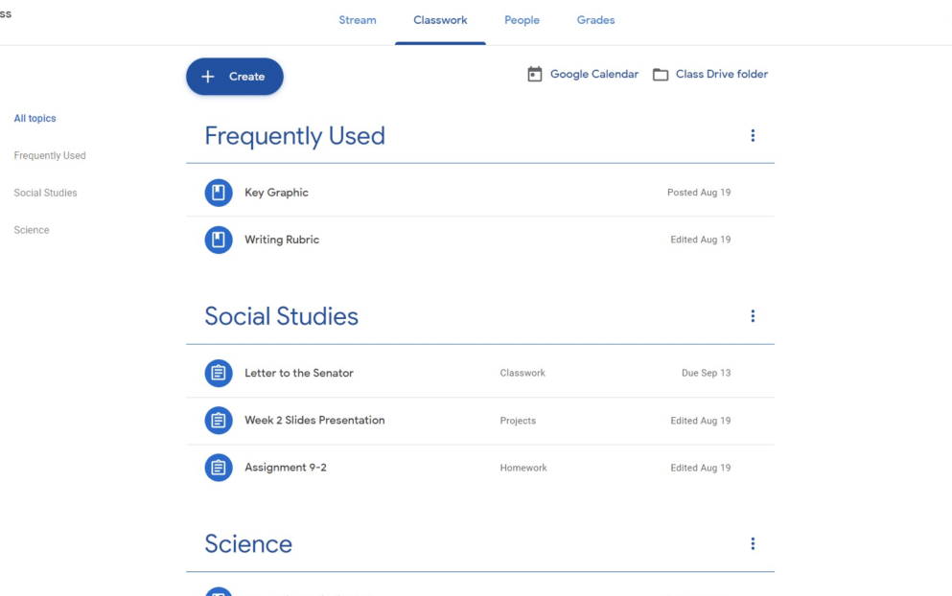
The student can access the class work by clicking the latest assignment or communication from the teacher. The assignments are dated and the latest assignments are positioned at the top of the list.

Everyone’s Responsibilities while partaking in distance learning
For students:
- Students must communicate with their @assumptionss.com account only.
- Students must be respectful with any comments or communication using the school online learning environment
- You cannot record or forward any content used in Google Classroom without permission of the creator of the content
- All online activity is recorded and logged. This includes anything you comment on in Classroom, email or Google meet. This includes monitoring of engagement with the work.
- Each student has their own timetable when it comes to engaging with their online work. Students should expect responses and feedback from teachers during school hours only.
For parents
- Parents should ensure that their child is checking in regularly for assigned work and completing tasks assigned to them.
- Live online classes are to be viewed by the student only; this is to ensure that every student is safe online.
- Try to keep the area where the student works as quiet as possible to ensure they can properly engage to the best of their abilities.

Resources
- https://www.pdst.ie/DistanceLearning
- https://classroom.google.com/
- https://www.webwise.ie/parents/
- https://cybersafeireland.org/parents/
- https://www.sess.ie/dyslexia-section/using-ict-home

Live online classes
Teachers may deliver some of the course “live” using Zoom. These classes may include a screen share of other resources like slideshow presentations.
In these classes:
- Students must follow the direction of their teacher just as in the classroom, the teacher can control your access to the camera or microphone and could be turned off if necessary
- A link to the class is intended for students of Assumption Secondary School only, do not forward a link to anyone else.
- Sessions may be recorded for students to watch again later on.
- Only a teacher is allowed to record a session. No one else is permitted to record.
- If a student is disruptive in the live classroom, they will be removed from the live class.
- Students must present in an appropriate manner for online classes.

