Dear Parents/Guardians,

As you know classes reverted to remote learning on Monday 11th for the month of January. This is so disappointing for us all and not what we were hoping for at the start of a new year.
However, we are hopeful that with the roll out of the vaccine we will in time return to more normal day to day living. For information on remote learning please check our school website.
We are aware of the difficulties faced by our families during this pandemic and we know that on-line education is a challenge. We ask that you continue to encourage your daughter to engage with on line classes and school work to the greatest extent possible, but encourage you to be realistic about your child’s needs and your own needs.

We are especially mindful of exam students and the stress that school closure can bring. When thinking about how we cope with uncertainty and stress, it can be helpful to remind ourselves of these three key messages:
- Stay Responsible & Informed
- Stay Active & Connected
- Stay Positive & Calm

On the following page we have created links to a range of resources which you may find helpful.

Please feel free to contact us on 01 4507017if you have any concerns.

Stay Safe.
Kind regards,
Assumption Secondary School

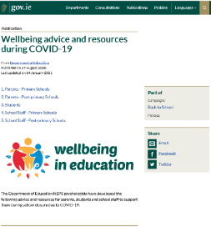
The Department of Education National Educational Psychology Service (NEPS) have many resources that you may find useful while the school is closed. These resources can be found on the Department website here and include the materails listed below.

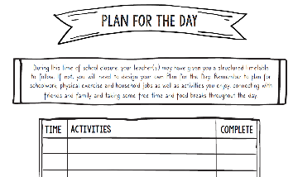
Plan for a Day
A plan for the day template is available here to help your child put a structure on the day. It suggests trying to have a schedule, creating time for fun activities, time for learning, break times and time for physical activity.

Advice for Young People
NEPS has published Advice for Young People while Schools are Closed which is available here

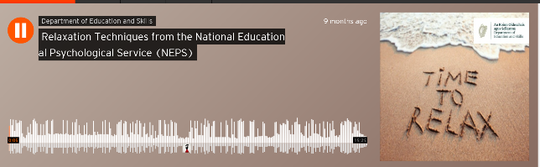
Relaxation Techniques Podcast
This link will take you to a podcast from NEPS to help parents and pupils practise relaxation techniques.

Advice for Parents
NEPS has also published A Guide for Parents on Supporting Children and Young People with Daily Routines while Schools are Closed which is available here

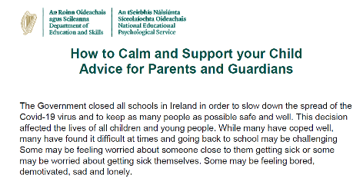
How to Calm and Support your Child – Advice for Parents and Guardians
This link here brings you to helpful tips and practical strategies to support your child if they become overwhelmed.
Managing Stress and Anxiety – A Guide for Parents and Guardians
Many young people have coped well with Covid 19 but many have found the ongoing situation upsetting and stressful. If they become more stressed and anxious
the following information here may be helpful.

